Predicting Economic Damage from U.S. Storm Events

Matthew Scarpello | Andrea Barfield | Sarah Parsons
October 4, 2026
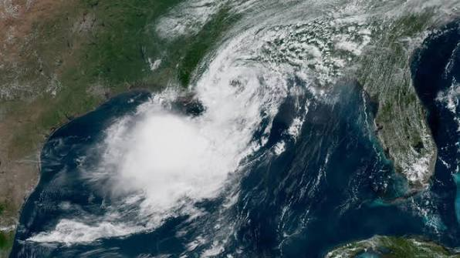
Image sources: National Oceanic and Atmospheric Administration (NOAA, n.d.).

Table of Contents

Introduction 2
Research Question 3
Methods/Analysis 4
Conclusion 5
References 6
Appendix A 7
Relative Intensity Feature Engineering 8
Recommendations/Ethical Considerations (10 Questions) 8
Appendix B 11
Ten Questions and Answers 12

Introduction
Weather forecasting is rooted in using data to reduce the uncertainty of our climate. Radar, satellites, and predictive models allow us to quantize and visualize weather events around the globe. However, radar cannot measure what that event will do to people, property, and communities. The consequences of severe weather are intertwined with a second form of uncertainty: impact. If meteorological characteristics can help forecast the occurrence of a storm, historical impact data may help us understand the likelihood that a storm will produce measurable economic damage. This project examines that question by connecting National Oceanic and Atmospheric Administration (NOAA) storm-event characteristics with recorded property and crop losses and testing whether those characteristics can be used to predict economic impact.
Business Problem/Hypothesis
Economic damage from severe weather is costly and difficult to anticipate, and the team wanted to test whether the characteristics NOAA already records about a storm event — before its full impact is known — carry enough signal to predict that damage on their own.

Research Question
Can we predict if a weather event will result in economic damage based on the recorded event characteristics in the NOAA Storm Events Database for U.S. storm events from 2020 through 2025?
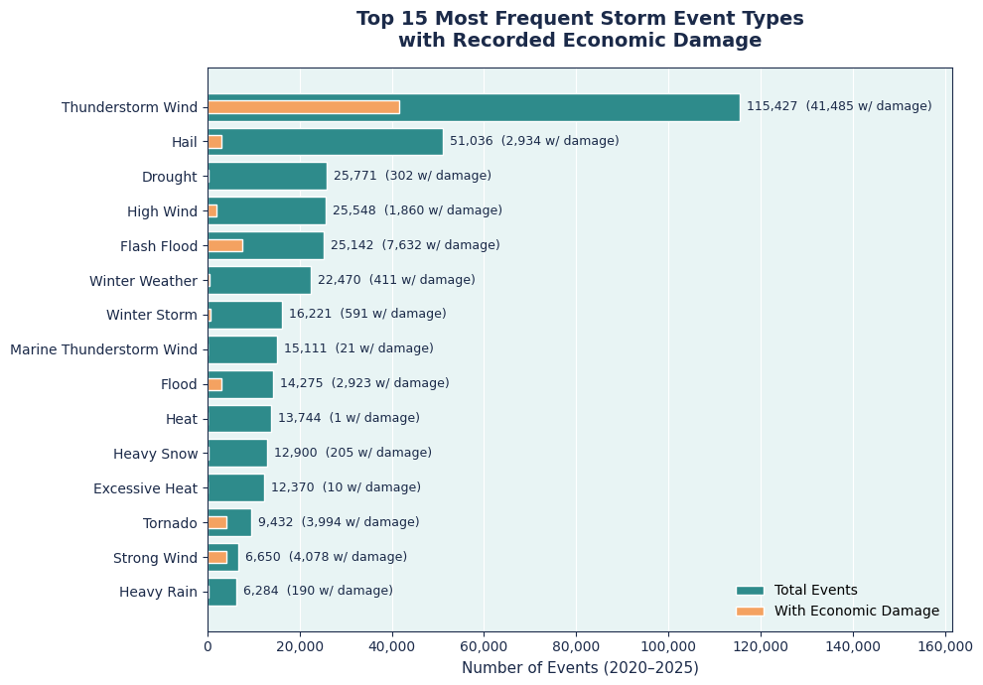
This chart establishes the scale of the problem by comparing how often different storm types occur with how often they are associated with recorded economic damage. The patterns are not the same: some common events, such as Hail, are rarely linked to damage, while less frequent events such as Tornado and Strong Wind show damage much more often. This difference suggests that event type contains meaningful information about economic impact and gives us a starting point for asking whether storm characteristics can be used to predict damage.
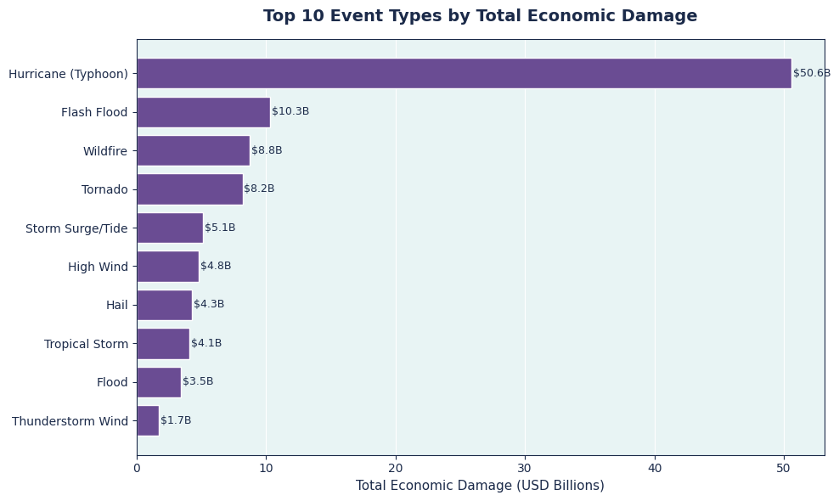
The amount of recorded economic damage also varies sharply across storm types. Hurricane events account for the largest total losses in the dataset, even though they are far less common than events such as Thunderstorm Wind or Hail. This shows that how often a storm occurs and how much damage it produces are two different parts of the problem. Together, these patterns suggest that storm characteristics may help explain which events are more likely to produce economic damage.

Hypothesis
Building on the patterns above, we hypothesize that event type is the strongest predictor of whether a storm event will be associated with recorded economic damage, with region, storm duration, and seasonal timing contributing secondary, supporting signal. We further expect that storm characteristics available near an event’s onset will predict recorded damage meaningfully better than a no-skill baseline, supporting the use of historical storm data for forward-looking risk assessment by emergency managers, insurers, and local governments.

Methods/Analysis
The project uses completed records from the NOAA National Centers for Environmental Information Storm Events Database from 2020 through 2025 (National Centers for Environmental Information [NCEI], 2026). We trained and compared two models using the same event-level information in order to test whether storm characteristics could predict recorded economic damage.

Results
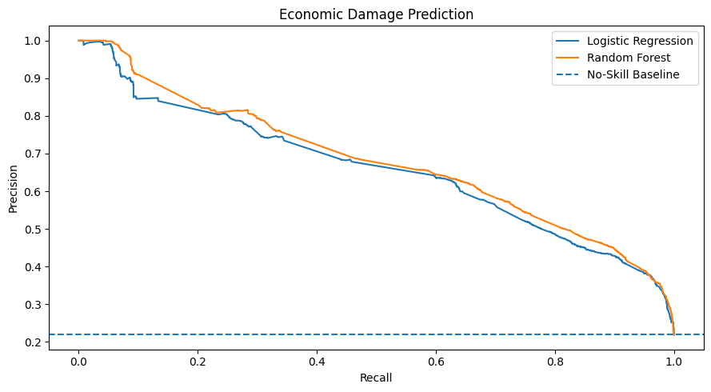
We tested two predictive models using the same storm characteristics: Logistic Regression and Random Forest. Both performed well above the no-skill baseline, showing that the recorded characteristics contain useful information about whether economic damage occurs. Random Forest performed slightly better, but the close results suggest that much of the predictive pattern can already be captured by the simpler Logistic Regression model.

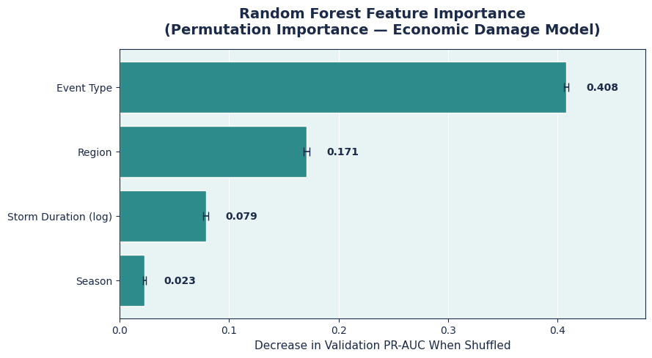
After training the Random Forest model, we examined which storm characteristics contributed most to its predictions. Event type was the strongest predictor, followed by region, storm duration, and season. This supports the patterns seen earlier in the analysis, where different storm types showed very different relationships with recorded economic damage. These results show predictive importance, however, and do not mean that event type alone causes economic damage.

Conclusion
Our results show that characteristics recorded in the NOAA Storm Events Database contain meaningful information about whether a storm event will be associated with economic damage. Both Logistic Regression and Random Forest performed well above the no-skill baseline, with Random Forest providing a modest improvement and event type emerging as the strongest predictor. These findings support our central research question while also showing that storm frequency alone does not explain economic impact.
The model represents only one part of a larger problem. NOAA property and crop damage estimates do not capture every consequence of severe weather, and storms with similar physical characteristics can affect communities very differently depending on the people, property, and infrastructure exposed. This reflects the broader understanding that climate risk is shaped by the interaction of hazards, exposure, and vulnerability (Intergovernmental Panel on Climate Change [IPCC], 2023).
Returning to where this question started: our interest wasn't just in whether a storm happens, but in what it costs once it does — the second, harder-to-forecast layer of climate uncertainty we opened with. The visualizations built for this project made that gap visible in a way the model alone doesn't. Heat and Excessive Heat are among the most frequent events in the dataset, yet almost none carry a recorded economic outcome, while far less common events like Strong Wind and Tornado are disproportionately tied to damage. That mismatch is exactly the kind of pattern a climate-impact lens is meant to catch: frequency tells you what's common, not what's costly, and as the mix of severe weather shifts, planning that leans on frequency alone risks preparing for the wrong thing. A model that predicts damage from event characteristics, rather than from how often an event type shows up, keeps that planning anchored to the risk that actually matters.
Future work could combine NOAA storm records with geographic risk and exposure information such as FEMA’s National Risk Index (Federal Emergency Management Agency [FEMA], 2024). Adding factors such as population, housing, infrastructure, and community vulnerability could help explain why storms with similar characteristics produce different levels of damage. Another direction would reverse the current modeling approach by testing whether patterns of property damage, crop damage, injuries, fatalities, location, and season can be used to predict the type of storm that occurred. This would expand the project from predicting the consequences of weather events to examining whether those consequences themselves form recognizable patterns across different storm types.

References
Doswell, C. A. (2007). Small sample size and data quality issues illustrated using tornado occurrence data. Electronic Journal of Severe Storms Meteorology, 2(5), 1–16.
Federal Emergency Management Agency. (2024). National Risk Index. https://hazards.fema.gov/nri/
Intergovernmental Panel on Climate Change. (2023). Climate change 2023: Synthesis report. IPCC. https://www.ipcc.ch/report/ar6/syr/
National Centers for Environmental Information. (2026). Storm Events Database. National Oceanic and Atmospheric Administration. https://www.ncei.noaa.gov/pub/data/swdi/stormevents/csvfiles/
National Oceanic and Atmospheric Administration. (n.d.). NOAA’s National Ocean Service: About us. U.S. Department of Commerce. https://oceanservice.noaa.gov/about/
National Oceanic and Atmospheric Administration. (n.d.). Weather. U.S. Department of Commerce. https://www.noaa.gov/weather
Verbout, S. M., Brooks, H. E., Leslie, L. M., & Schultz, D. M. (2006). Evolution of the U.S. tornado database: 1954–2003. Weather and Forecasting, 21(1), 86–93.

Appendix A
Item |  | Project Detail
Data source |  | NOAA National Centers for Environmental Information Storm Events Database
Study period |  | January 1, 2020–December 31, 2025
Unique storm events |  | 410,311
Known economic outcomes |  | 307,902 events
Unknown damage totals |  | 102,409 events (24.96%)
Recorded $0 damage |  | 237,603 events (77.17% of known outcomes)
Recorded damage > $0 |  | 70,299 events (22.83% of known outcomes)
Prediction target |  | Whether an event had recorded property or crop damage
Predictors |  | Event type, region, season, and storm duration
Models |  | Logistic Regression and Random Forest
Evaluation |  | Average Precision and ROC-AUC
Model | Average Precision |  | ROC-AUC | Interpretation
No-Skill Baseline | 0.219 |  | 0.500 | No useful predictive information
Logistic Regression | 0.652 |  | 0.871 | Strong predictive signal
Random Forest | 0.669 |  | 0.880 | Best overall performance; modest improvement

Relative Intensity Feature Engineering
NOAA does not measure intensity the same way for every storm type. For example, hail may be measured by hail size while wind events may be measured by wind speed. To make these values more comparable, relative intensity ranks an event against other events of the same type rather than comparing incompatible measurements directly. DSC450_Milestone1_Final_Proposal On the subset of events where this comparison was possible, adding relative intensity increased Average Precision from approximately 0.691 to 0.703. This suggests that storm intensity adds some predictive information, although the improvement was small and does not apply to every event type.

Recommendations/Ethical Considerations (10 Questions)

Stakeholder Impact
This analysis could impact emergency management agencies, local governments, insurers, and communities that are affected by severe weather events. Emergency management agencies could use the results from this model to identify historical characteristics of high-impact storms. That information could help them prepare and allocate resources appropriately. Regional patterns identified during this analysis could help local governments understand the types of storms and their impacts that are prevalent in their area. They could also aid emergency management agencies in preparedness and planning prior to storm events. Insurance companies could potentially use this analysis for risk assessment. It could provide them with patterns for event type impact in specific areas. If the already presented stakeholders use the insights of this analysis appropriately, communities, and the individuals within them, could be better informed and more prepared for severe weather. However, negative effects of this analysis could appear if the stakeholders rely too heavily on the results of the model, specifically in regards to severe weather events that are less common or less frequently recorded.

Data Assumptions and Potential Bias
This analysis assumes the data collected from NOAA is accurate and complete. There are missing values within the dataset that can be attributed to different measurements recorded for each storm type. There are also storm types with very few observations. Historical severe-weather databases can be affected by changes in reporting practices and data quality. Recorded event patterns should not automatically be treated as a complete representation of all severe weather activity (Doswell, 2007; Verbout et al., 2006). These null values and differences in frequency could affect the results of this analysis. Because the analysis is based on historical data from 2020 to 2025, the model assumes that future events can be predicted based on these patterns. This does create a limitation when interpreting the model’s results. To reduce the potential for these issues, the data was cleaned and validated before modeling. However, this cannot eliminate the potential bias that may exist in the original data. The model still depends on the quality and completeness of the original NOAA records.

Ethics of Data Retrieval
All data used in this analysis comes from NOAA’s publicly available National Centers for Environmental Information Storm Events Database (NCEI, 2026), a government source collected through official storm reports rather than from individual people directly. Because the dataset records event-level characteristics — location, timing, event type, and damage estimates — rather than information about specific individuals, no personal consent process applies, and no personally identifiable information is present in the data the team worked with. This project uses the publicly available NOAA dataset for analysis only, and does not claim ownership of the original records.

Misinterpretation & Misuse Potential
These results could be misread as predicting whether a specific future storm will cause damage, when in fact the model describes historical patterns in recorded outcomes, not physical certainty. A low predicted likelihood of damage could be misinterpreted as a guarantee of safety, which the data cannot support given how many events have no recorded economic outcome at all. Similarly, because event type and region are the strongest predictors, stakeholders could mistakenly treat these relationships as causal — assuming, for example, that a region is inherently higher-risk — when the model is identifying statistical association, not a physical cause of damage.

Responsibility
The team is responsible for clearly communicating what this model can and cannot support: it estimates likelihood based on historical, recorded outcomes, and it should inform — not replace — the judgment of emergency managers, insurers, and local governments. If these findings were used to justify withholding resources from a region or event type based on a lower predicted probability, that would be a misuse of a correlational model, and the team has a responsibility to state these limitations plainly wherever the analysis is shared or built upon. This model is meant to support decision-making prior to a storm event, it cannot replace human judgment.

Appendix B

Ten Questions and Answers
1. Why did the team model “any economic damage” rather than a high/low severity threshold?
Because roughly 25% of events have no recorded economic outcome at all, distinguishing known damage from no recorded damage proved a cleaner, better-supported target than an arbitrary severity cutoff.
2. Why report Average Precision (PR-AUC) alongside ROC-AUC?
With the positive class at roughly 23%, Average Precision is more informative under this imbalance. ROC-AUC independently increases the potential for the model to overstate how well it actually finds damage-associated events.
3. Why split the data by EPISODE_ID instead of by individual row?
Events from the same storm episode share nearly identical characteristics. A row-level split would let the model see near-duplicate records across training and testing, inflating apparent performance.
4. What does it mean that event type is roughly 2.4 times more important than region?
Storm type itself carries most of the predictive signal about damage likelihood. Region adds real but secondary context — useful for refining predictions, not driving them.
5. Why do Tornado and Strong Wind show much higher damage rates than Hail, despite Hail being far more frequent?
Hail events are common but often fall under NOAA’s damage-reporting thresholds. Tornado and Strong Wind events are more rare, but also more reliable to produce recorded damage when they occur. Frequency and damage are separate dimensional likelihoods of the same problem.
6. How reliable is the relative-intensity feature, and why wasn’t it applied to every event type?
NOAA uses different event types to measure intensity (for example, wind speed versus hail size). Therefore, the feature is only valid where enough comparable magnitude data exists. Applying it inconsistently would introduce its own bias.
7. How was the 25% of events with unknown economic outcome handled?
These events were excluded from modeling. An unknown dollar figure could mean there was none or an amount that wasn’t recorded. Imputing an unknown value would risk fabricating a signal the data doesn't actually support.
8. Could this model be used to decide where to save disaster-response resources?
In short— no. Based on historical recording patterns, the model estimates likelihood. Ground-truth risk is not connected to this. Using it to justify withholding resources from a region or event type would be a misuse of a correlational tool.
9. What would most improve this model’s real-world usefulness next?
Incorporating exposure and vulnerability data, such as FEMA’s National Risk Index, so predictions reflect not just storm characteristics but who and what is actually in the storm’s path.
10. What is the team directly responsible for if this analysis is used downstream?
Clearly documenting the model’s limitations — the known-outcome gap, the correlational rather than causal nature of feature importance, and the historical-data assumption — anywhere these results are shared or reused.

